import matplotlib.pyplot as plt

import numpy as np

import cv2

from keras.preprocessing.image import img_to_array

from tensorflow.keras.layers import Input,Dense,Conv2D,MaxPooling2D,UpSampling2D

from tensorflow.keras.models import Sequential

img_data=[]

img=cv2.imread("/content/drive/MyDrive/lena15.jpg",1)

SIZE=256

img=cv2.cvtColor(img,cv2.COLOR_BGR2RGB)

img=cv2.resize(img,(SIZE,SIZE))

plt.imshow(img)

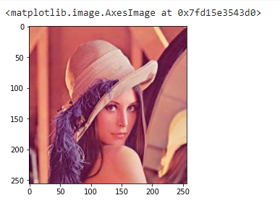

img_data.append(img_to_array(img))

img_array=np.reshape(img_data,(len(img_data),SIZE,SIZE,3))

img_array=img_array.astype('float32')/255

model=Sequential()

model.add(Conv2D(32,(3,3),activation='relu',padding='same',input_shape=(SIZE,SIZE,3)))

model.add(MaxPooling2D((2,2),padding='same'))

model.add(Conv2D(8,(3,3),activation='relu',padding='same'))

model.add(MaxPooling2D((2,2),padding='same'))

model.add(Conv2D(8,(3,3),activation='relu',padding='same'))

model.add(MaxPooling2D((2,2),padding='same'))

model.add(Conv2D(8,(3,3),activation='relu',padding='same'))

model.add(UpSampling2D((2,2)))

model.add(Conv2D(8,(3,3),activation='relu',padding='same'))

model.add(UpSampling2D((2,2)))

model.add(Conv2D(32,(3,3),activation='relu',padding='same'))

model.add(UpSampling2D((2,2)))

model.add(Conv2D(3,(3,3),activation='relu',padding='same'))

model.compile(optimizer='adam',loss='mean_squared_error',metrics=['accuracy'])

model.summary()

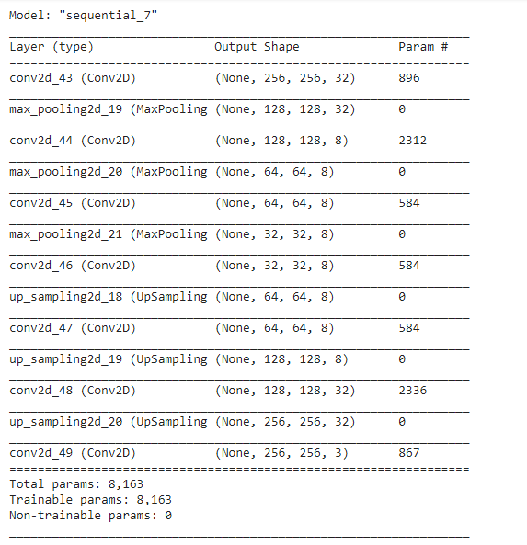

model.fit(img_array,img_array,epochs=500,shuffle=True)

pred=model.predict(img_array)

plt.imshow(pred[0].reshape(SIZE,SIZE,3))

